# xpedx.com Next generation

# *My Items List Design Document*

**Authors: Sterling Commerce**

**Date Created:** 04/12/10

**Last Updated:** 07/19/10

**File Name:** C:\Documents and Settings\bfurman\My Documents\Temp\Methodology v1.1\Project Management\TEMPLATE - DOCUMENT - Use Case Definition.docxpedx My Item List Detail Design Doc V1.12.docx

Approval Signatures (Mandatory)

|  |  |  |  |  |
| --- | --- | --- | --- | --- |
| **Title** | **Name** | **Signature** | **Date** | **Comments / Issues / Concerns** |
| **xpedx Owner(s)** | Steve Bugher |  |  |  |
| Cheryl Tullis |  |  |  |
| **Sterling Commerce Owner(s)** | Guy Read |  |  |  |
|  |  |  |  |

**Note**: The sign off indicates approval of all sections of the document.

Document Revision History

This chart tracks the changes introduced by the revisions to the document as the project progresses through the stages of the System Development Life Cycle (SDLC).

| Version | **Date** | **Description (Changes Made)** | **Author(s)** |
| --- | --- | --- | --- |
| 1.0 | 04/12/2010 | Initial Draft | Sterling |
| 1.1 | 04/16/2010 | Ready to deliver | Sterling |
| 1.2 | 05/20/2010 | Incorporated feedback from xpedx | Sterling |
| 1.3 | 06/03/2010 | Incorporated feedback from 6/1/10 meeting with Steve, George, Cheryl, Chris, Jasmine | Sterling |
| 1.4 | 06/08/2010 | Open questions were answered | Sterling |
| 1.5 | 06/11/2010 | More Feedbacks | Sterling |
| 1.6 | 06/17/2010 | Feedback on Share List Edit functionality | Sterling |
| 1.8 | 07/07/2010 | Updated based on feedback on csr access to MyItems list | Sterling |
| 1.9 | 07/07/2010 | DDD Marathon review items | Sterling |
| 1.10 | 07/15/2010 | Support for CSR MyItems List in Call Center | Sterling |
| 1.11 | 07/15/2010 | Quick Add work flow change to handle special item | Sterling |
| 1.12 | 07/19/2010 | Answered the question about no validation during my item list import | Sterling |

Related or Reference Documents

| Document Name | Description | Owner | Location |
| --- | --- | --- | --- |
| SCI_Xpedx Solution Definition Document v1.5 | Solution Definition document | Sterling Commerce |  |
| Xpedx Replacements Detailed Design Document v 1.1 | Detailed Design Document | Sterling Commerce |  |

TABLE OF CONTENTS

1. Introduction 5

1.1 Document Purpose 5

1.2 Document Audience 5

2 My Items List 6

2.1 Functions & Solution 6

2.1.1 My Items List Page 7

2.1.2 My Items List Detail Page 8

2.1.3 Quick Add to My Items List 8

** The same workflow applies for Shopping Cart Quick Add as well. 9

2.1.4 Import /Export My Items List 9

2.1.5 Add Items from the catalog 10

2.1.6 Add to Cart from My Items List Detail Page 10

2.2 Master System 10

2.3 Implementation Details 10

2.3.1 Entity objects. 10

2.3.2 Actions classes involved 10

2.4 Process Flow 11

2.5 Screen Shot 12

2.6 Open Questions 15

2.7 Assumptions 15

3 Glossary of Terms 16

# Introduction

## Document Purpose

This document is the governing functional design document for My Items List functionality. It presents significant decisions and constructs used in developing the functionality. Testing, builds, configuration management are not covered in this document.

The document will also serve the purpose of keeping a list of assumptions that were made during design discussions.

## Document Audience

This document is intended for management and technical staff working on this project, xpedx IT and Business, webMethods, Legacy(MAX and ACCESS), HP, IW, xpedx/IP Network Team. Sterling will use the document during design and configuration for design consideration.

# My Items List

## Functions & Solution

My Items List is a wish list of items that the customer orders frequently. Each customer / user can have multiple My Items list and can choose to order items from either a single list or items from multiple lists. My items lists are stored against a user and the customer in the Sterling database. The following are the ways the user can add items to their My Items List.

* Import items using CSV template
* Browse / Search catalog and add items
* Add from the Item Details Page
* Add from the Item Compare Page
* Quick Add from the List Details Page.
* Add items from the Cart page.

While creating a new Items list, depending on where the user has access in the customer hierarchy, he will be able to assign the List to a Master Customer, Customer, Bill-To or a Ship-To or keep the list private to himself. All users can create personal list. Buyer users cannot share the list with any other user. They can only create private lists. Customer Admin users when creating a list has the option to keep the list private or share it with accounts and shipto’s.

There will be a flag “Can be edited by admin users only” which when checked can only be edited by the admin users in the customer’s organization hierarchy. Buyer users if authorized can see it but they will not be able to edit the list. The edit button will be hidden in that case for buyer users for those lists. If the flag is not checked, then all the users who are authorized to see the lists can edit the list but buyer admin users can only edit the sharing functionality. In this case, the buyer users can edit / delete the list but they cannot change the authorization of the lists. Private lists are only edited and seen by the user who created the list.. This is the typical My Item List Authorization.

Items can be added to the List either by selecting items from the catalog (browsing / search) or by importing items through the import My Items List functionality.

The read permission will be the list of My items that the user is authorized to and not the ones authorized to the ship to selected by the user. The list can be filtered either by Bill-To, Ship-tos or the personal lists for the user. By default the personal lists would be shown. Please see the ‘My Items List’ screenshot.

All users except CSR’s, including Customers, and SalesReps will have access to Web Channel to create and manage MyItems lists.

Support for simple MyItems creation and management will be provided in Call Center (COM) on a schedule to be agreed. A separate Design Document for this function will be created, also on a schedule to be agreed.

**Replacement Tool in COM** – This is a page in COM where the items can be replaced globally for a Customer or Division in the My Items Lists. This is a custom page that needs to be built with the following logic.

Steps to replace items:

* xpedx Admin user come to this page and enters the Legacy product code that needs to be replaced and also the replaced Legacy product code.
* Then the user selects one option from the drop down:
* Select customer (SAP level ex: Kohls) – The list of customers would contain all the customers in the hierarchy.
* Select division - This should allow multiple divisions to be selected. From the drop down the user can select a division at a time but those divisions can be added to a text area as they select those divisions and when they click on generate all the divisions will be passed from the text area.
* User selects the customer (master customer level) - There could be drop down with all the customers at that level or we can ask to enter the SAP number.
* After the customer is selected click the generate list button. This will generate a list of all My Items authorized to this customer with Customer name | Division name | My Items List name.
* The list view will have a checkbox. By default all the My Items will be checked. If the user doesn't want to change that My Items list the user should uncheck the checkbox for that My Items list.
* After reviewing the user will commit the changes and the My Items list will be updated.
* No other output or report will be generated.
* User selects multiple divisions from the list of divisions provided.
* User clicks on generate list button.
* This will generate a list of all My Items authorized at those divisions with Customer name | Division name | My Items List name.
* The list view will have a checkbox. By default all the My Items will be checked. If the user doesn't want to change that My Items list the user should uncheck the checkbox for that My Items list.
* After reviewing the user will commit the changes and the My Items list will be updated.
* No other output or report will be generated.

My Items List Size – The size of the list will be restricted to 200 items. If the customer wants to add more than 200, they will have to create another List and add the extra items in the new list. This will be restricted both all scenario for users adding items to the My items list, whether it is being added from the catalog, cart or they are being imported through import functionality.

## My Items List Page

This page displays all the My Items List the user has created or assigned as part of authorization. The following fields will be shown as column headers on the List page, and the columns headers are sort able. Please refer to screen shot ‘My Items List Page’ in the Screen Shot section of the document.

* List Name & Description along with Number of items in the List. - This field is a hyperlink to the List detail page. User can click and open the List.
* Modified By
* Last Modified Date
* Actions – The following actions are permitted at the List level
  1. Open List – Goes to the List Detail page.
  2. Import List - User needs to create the list first. Then they can select import to import the list. Also if the user wants to import to existing list, the items will be added to the list and list won’t be overridden by new one.
  3. Export List – Exports the List in the same format as Import List.
  4. Copy List – Copies the items from the existing List to a New List. A new Name and Description is required for the new List.
  5. Delete List – Deletes the List.

Header Level Actions - Create New List. – The List name does not need to be unique. The authorization will be included on the same light box with name and description of the list. Also, there will be a flag “Can be Edited by Admin users only”. The functionality of the flag is mentioned above in the document. At this point the authorization can be given to an account and location or it can be kept private. These options will be available as radio options.

## My Items List Detail Page

This page displays the details of a particular List. It has on demand P&A call upon which the list of items will show price and availability. User should be able to update quantities on line items or can change the Customer line account number, Customer line fields 1, 2, 3 and UOM. This page also shows Related Items which are nothing but cross-sell and up-sell items related to the items in the list. The Cross-Sell and Up-Sell items are fetched from the item definition set at the national level and the complimentary and upgrade items from the item division feed.

Replacement Items will be shown as defined in the Item Replacement DDD.

Alternatives will be shown in the Relative items in the carousal below.

Please refer to the screen shot ‘My Items List Detail Page’ in the Screen shot section of the document. The following actions can be performed from the list detail page.

* Edit the name and description of the List. (in edit mode only)
* They can edit qty, UOM, Customer line account number, Customer line fields 1, 2, 3 as well. (In non edit mode these changes are not saved. This will be saved only in edit mode)
* Quick Add
* Selective or Select All for Price and Availability check
* Remove items (in edit mode only)
* Add Items within List to Cart – This will be a global add and all the items having qty greater than zero within the list are added to a new or existing cart.
* ~~Add Entire List to Cart – Add all the items in the List to the active cart or select a different cart. Or create a new cart.~~
* For global Add to Cart, only those items whose quantity is greater than Zero will be added to the cart.
* Sequence number (only in edit mode)
* Export button

## Quick Add to My Items List

Quick Add is one of the channels to add items to My Items List. Item Validation will not be done as part of the add process. Whatever part # the customer specifies, it will be added even though it is not a valid item in the catalog. So, no entitlement or product check will be done when adding items to My Items List. Copy and Paste is another quick way to add items to the My Items List. When the user clicks on the Copy & Paste link in the Quick add window, a modal will open up and the user can enter xpedx# and qty and click Add to add it to the List.

*Steps for Quick Add*:

* User can enter Customer Line Level fields, Qty, Item#, Item type, and then select Add to Quick List.
* Item type options would be xpedx #, customer part #, MPC #, Manufacturer #
* Before adding the item to Quick list, the items are validated and the valid UOM are populated. If the item doesn’t exist in the catalog then a message will be displayed and a link will be provided against that item to add it as a special item to my item list.
* Upon clicking on the link to add the item as special item, a light box will appear where item description, uom and qty can be entered.
* There will be button to add the items to My Items list.

## ** The same workflow applies for Shopping Cart Quick Add as well.

## Import /Export My Items List

After a List is created, users should be able to import a list of items through a CSV file. The user adds information to the CSV template and saves the file as CSV. When they click on Import Action, it should open a dialog box or take the user to a intermediate page where the user should be able to browse to the file and Click Import button. After the button is clicked the items will be imported to the selected List. No validation will be performed while importing list of items using this functionality (this includes no entitlement check and no check for item being in the catalog). The current CSV file has the following fields:

Import format fields:

* Customer Part # - customer specific sku
* Supplier part # aka xpedx Part #
* Quantity
* Unit Of Measure
* Customer defined fields [1 to 5] - They show up based on the customer profile selection. The labels for the fields are going to be shown.
* Description – Product description, this will be used for special items or the items which we did not find in the catalog. For the ones we found in the catalog, the desc will be used from the catalog and will ignore this description.

Export format fields:

* Customer Part # - customer specific sku
* Supplier Part # - xpedx part#
* Quantity
* Unit Of Measure
* Customer defined fields [ 1 to 5]
* Description
* Price

Big Open Question: Import of MyItems list should be validated against customer entitlement to ensure that the item is a valid, entitled product. Sterling: The answer is the import will have no validations.

## Add Items from the catalog

Users can browse the catalog or search items from the catalog and will have an option to add items to an existing My Items List. The option for adding items will also be available from the Item details page and Compare Page.

## Add to Cart from My Items List Detail Page

There are two options to add the items from the List to Cart, either add the whole where the quantity is greater than zero. The list of all the existing carts for the user is available in a drop down menu. When the user chooses to add it to a new cart, they need to click on the new cart option from the drop down.

Based on customer’s entitlement and valid item rule the following scenarios can happen:

* Customer is entitled to buy and it is a valid item in catalog– In this case, the item will be added to the cart successfully with the quantity and UOM mentioned against the line item during add to cart.
* Customer is entitled to buy the item but the item is not a valid item in the catalog – Add the item as a ‘Special’ in the Cart.
* Customer is not entitled to buy the item and the item is a valid item in the catalog - Add the item as a ‘Special’ in the Cart.
* Customer is not entitled to buy the item and the item is not a valid item in the catalog - Add the item as a ‘Special’ in the Cart.

## Master System

Sterling is the master of system to maintain and create My Items Lists.

## Implementation Details

## Entity objects.

Create the following custom entity objects to store the List and Detail information for My Items List.

* XPEDX_My_Items_Items.xml – This entity stores the List level information, such as List Key, CustomerID, createdBy, Date of Creation, Modification etc.
* XPEDX_My_Items_List.xml – This entity stores line level information for the List, such as Part #, Job#, UOM, Quantity, Item Type etc.

## Actions classes involved

Create the following actions to view, edit and manage My Items List. Few more needs to be identified for My List authorization functionality.

* XPEDX MyItemsDetailsAction.java – Fetch and Display My Item’s Details page.
* XPEDX MyItemsDetailsAddFromCatalogAction.java – Add items from catalog to My List action.
* XPEDX MyItemsDetailsChangeAction.java – Modify action to change List Details and save the changes.
* XPEDXMyItemsDetailsCreateAction.java – Creates a new line item.
* XPEDX MyItemsDetailsDeleteAction.java – Deletes a line item.
* XPEDX MyItemsListAction.java – Show the List of all the My Items List.
* XPEDXMyItemsListChangeAction.java – Modify the List object.
* XPEDX MyItemsListCreateAction.java – Create a new List object.
* XPEDX MyItemsListDeleteAction.java – Delete a List object.

## Process Flow

Not Applicable

## Screen Shot

The screen shots pasted here are still in review and not final. This is just an illustration of how it should look like.

***My Items List Page –*** *In this screen the Import New Items should be removed from the header*

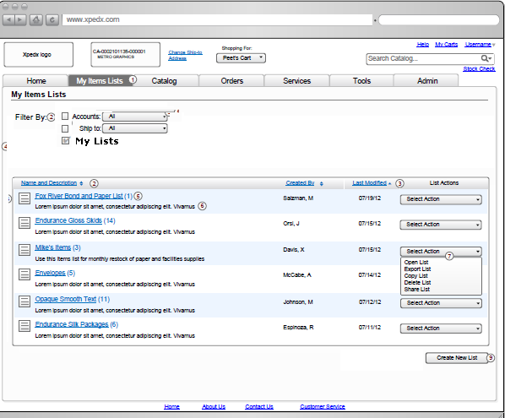

***My Items List Detail Page (non-editable view)***

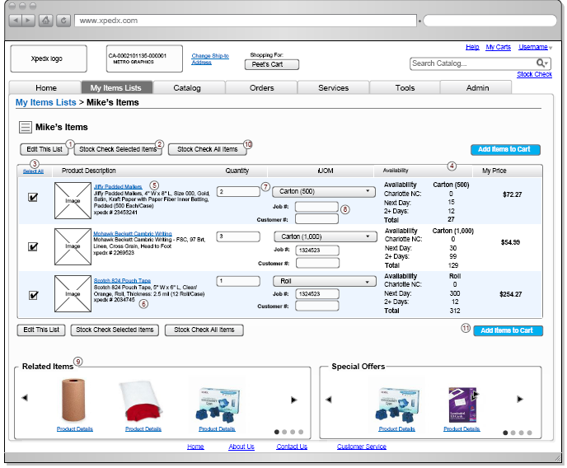

***My Items List Detail Page (editable view)***

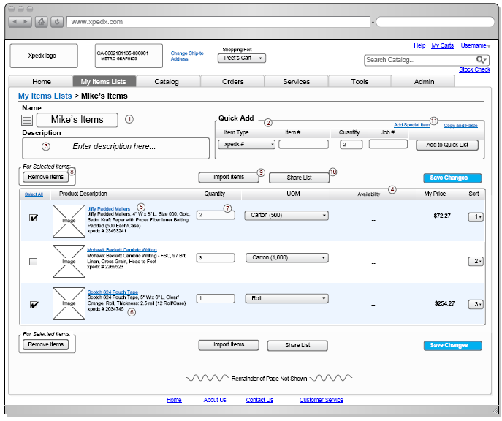

## Open Questions

1. Is there a reason why the Import New Items is a header operation and Export List an action at the List Level? Answer: It will be a line level action, meaning a list has to be chosen or created and then items could be imported to that list.
2. If a user is given authorization to a List, should he be able to delete the list, add / remove items from the list etc? Answer: YES.
3. Can the List created and assigned to the customer level authorization be edited and deleted by users or location users? Answer: YES
4. Special Offers functionality needs to be evaluated, are these promotions for the items in the List? Answer: Confirmed with Steve, George and Jasmine – This is just an advertisement real state on the Sterling Cart and My Items List Page and the page will have a link to an external web server which will host the advertisement. The link will fetch the advertisement and render it on the page.
5. Why do we have the List Actions in the My Items Detail Page? Answer: This will be taken off the screen.
6. Need to understand how to roll up inventory results coming from P&A and show them in the hover proposed by IW. Answer: Resolved
7. Share List function is this same as Authorization in the current xpedx.com? If not it is a new scope item. Answer: This is the same functionality.
8. Can we have the update button as line level action instead of a global action? If not the user has to choose the select box on the left and then modify the line and click save. Answer: Header Level Save button is fine.
9. Is there a default UOM per item from the list of UOMs? The quick add talks about adding the item with the default UOM, where are we getting the information about the default UOM. Answer: the default UOM logic is the same as described in the UOM DDD.
10. Screen Flow for Import items to My Item List is missing from the current design pages. Answer: xpedx to work with IW to get the screens.
11. My Items List Migration approach and plan needs to be hashed out. Answer: Sterling needs to finalize on solution.
12. When the user does an on – demand P&A call for items in the My List, and if they are not available do we need to present the user with the list of alternate, replacement and complimentary items. Or this should be done in Cart only. Answer: The replacement, alternate items are shown if they are present for the item and are displayed without P&A check as well.

## Assumptions

1. There won’t be any P&A check option on the My Items List Page. P&A is done from the List Detail Page.
2. Lists created and assigned at Customer or Location levels are available to the users in the hierarchy.
3. No checks will be performed to check if the My Items List name entered is unique.
4. Availability information is not stored in the session, every time the availability needs to be shown for the My Items List Detail page, the interface needs to be invoked. What is the behavior when a users lands on list detail page. I believe P&A is not invoked until user clicks on P&A button, so price and availability will be blank? [Pawan]: Yes
5. When the customer adds an item through quick add and choose item type to be xpedx#, customer#, MPC# or manufacturer # we will look into the corresponding filed to query.
6. Related product carousel at the bottom of the My Items List page is a collection of all the Cross-Sell and Up-Sell items from the item master feed from data point at the national level as well as complimentary and upgrades items from the division item feed.
7. Duplicate item lines will not be checked either in the List or in the Cart or during add to cart. If the user has more than one line for the same item, they will appear more than once and no quantity consolidation or merging will happen.
8. Quantities will not be saved for an item automatically, the save / update button needs to be clicked.
9. If the authorization of a list is at the Bill to or at a higher level and not to specific ship-tos, then any new ship-to created under that hierarchy will automatically have the authorization to that list.

# Glossary of Terms

|  |  |  |
| --- | --- | --- |
| S. No. | Term | Definition |
| 1. | Entity Object | Database and Java entity objects to store the required data. |
| 2. | Action Class | Struts controllers which redirects the parameters and does some business logic before calling the business APIs. |
| 3. | My Item List | Wish List of Items |
| 4. | BR1 | Business Release 1 |
| 5. | IW | Industrial Wisdom – UI firm engaged on the project. |
| 6. | OOTB | Out Of the Box Sterling system |
|  |  |  |